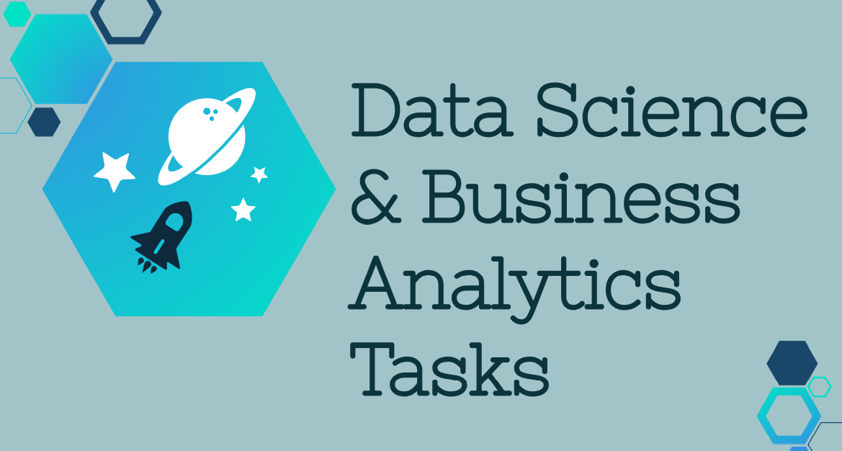

All tasks are completed by Ameya Harshad Chaudhari

Task 2: Prediction using Unsupervised ML

● From the given ‘Iris’ dataset, predict the optimum number of clusters

and represent it visually.

● Use R or Python or perform this task